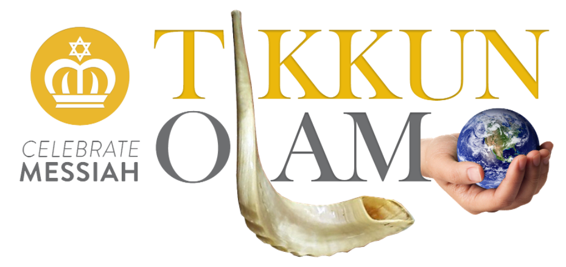

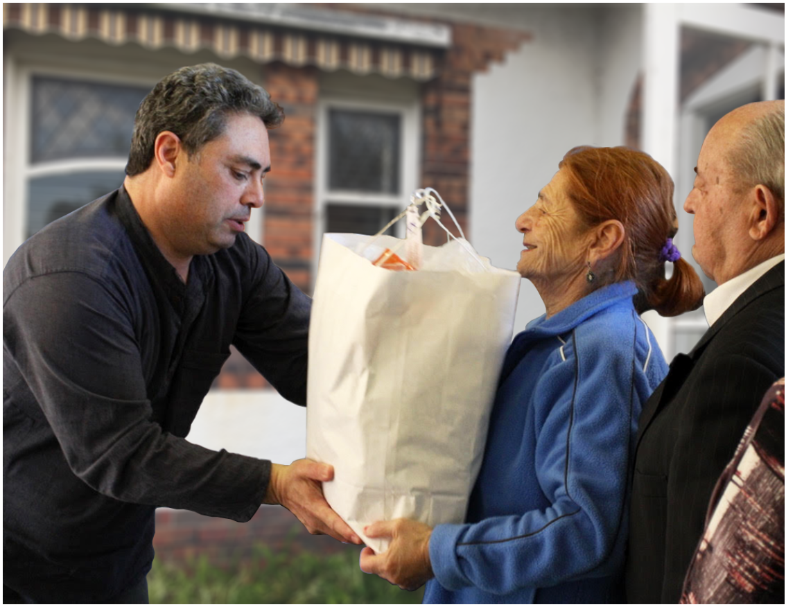

Tikkun Olam End Of Financial Year Report 2016 - 2017

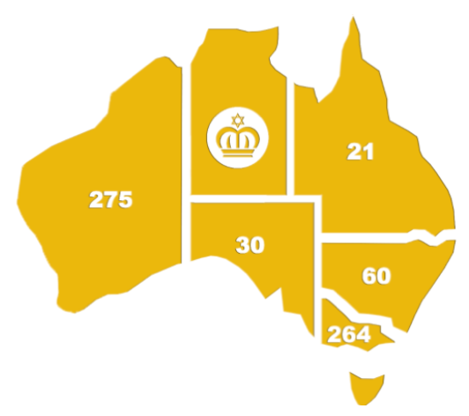
In the financial year of 2016-2017 Tikkun Olam has distributed the following hampers across Australia:

State No
Victoria 241
New South Whales 60
South Australia 30
Western Australia 275
Queensland 21
Vic (basic hampers) 23

Total Number of Festival & Basic Food Hampers 650 = $36,000
114 Volunteers have partnered with us for purchasing, packing and delivering.
When Words or (Testimonies) Matter - Why then are words necessary?
It’s not that God needs to hear the words. He hears the things that are not articulated – but the words are important for us. The human being is unique, say the sages, because of “ru’ach m’mall’la – the spirit of speech”. Bereshit (Genesis) 2:7 tells us “Then Adonai, God, formed a person from the dust of the ground and breathed into his nostrils the breath of life, so that he became ‘nefesh chaya” - a living being.” Fascinatingly, the Targum Onkelos printed next to the Hebrew text in so many chumashim, which is generally a straightforward translation of the Hebrew into Aramaic, translates the words “nefesh chaya” as “ruach m’mall’la”. Clearly the ability to speak is the essence of man. Words matter to the speaker, not just to the listener.

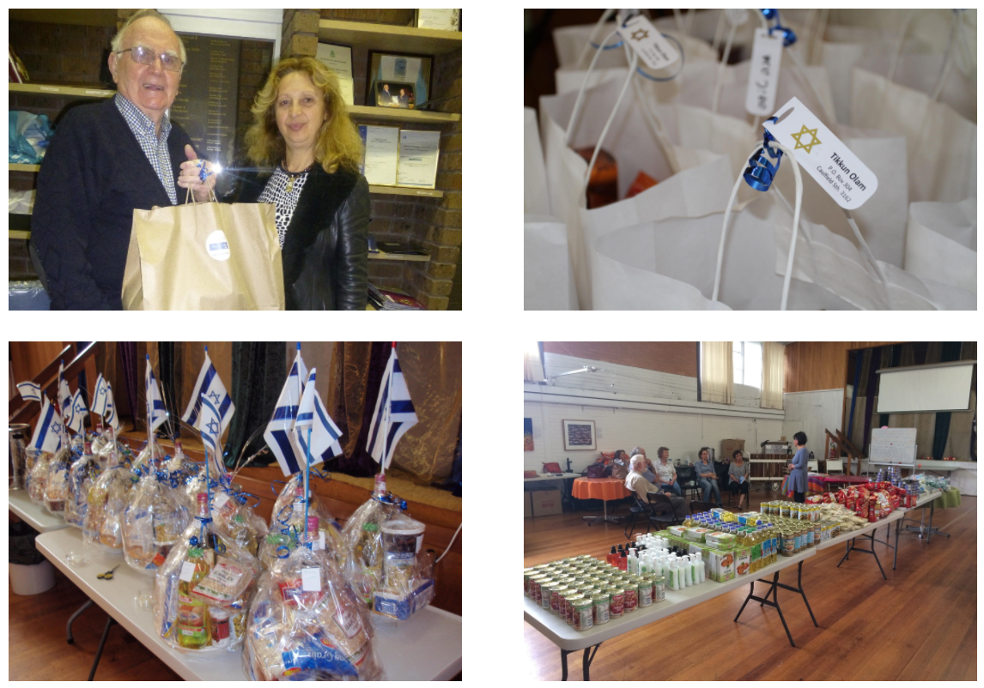

Perth Tikkun Olam Report
Dear Peter, I would like to take this opportunity to wish you and your family good health and prosperity for the feast of Shavuot. For a number of years, you, your team and Tikkun Olam have been kind and generous in working with The Menora Charity Fund in supplying food hampers for the less fortunate in our Jewish community. At the beginning we would only receive 4 food hampers each feast. Todate your team has delivered 55 food hampers to our clients on each festival. Much to our regret, in WA we have an ever-growing number of people experiencing hardship, due to the downturn in the economy. The food hampers that you have distributed are of great value due to the fact that the recipients do not have the means to purchase items of such luxury. As for the feedback, it is most humbling to see the receivers having tears in their eyes and being moved by the fact that they are being thought of. As for the children the glee on their faces cannot be described or purchased. May those lovely thoughts continue in the hearts and minds of the Tikkun Olam ministry, and may you all always be given the means and the will to be your own brother’s keepers. On behalf of the recipients i would like to thank the principals, yourself and the team for all the unconditional and extended efforts in assisting the needy. With much blessing. Phillip.
Hi Josh, our Jewish Father Christmas, thank you so much, we are ever so grateful for our Yomtov treats you give us. It makes us smile with joy to know we are blessed. It is lovely to know there are still such kind people in this world. Love Donna and Rachael.
Dear Tikkun Olam, I write to you to thank you for all that you do. Every Chag I struggle as a single mother of now 3 to put the basics on the table for the meal never mind treats for my children to make it extra special for them. Every Chag no fail you have come and dropped off a brown bag full off goodness and a special treat for the children. I would like to formally thank you and tell you how much your work and assistance and gifts are appreciated to no end.
You are doing wonderful work and I can only describe the excitement on the faces of my children when they get the special treats for the Chag. Could you please send me some details or a way to donate on some months when we have a little bit left over to give. I wish you a most wonderful Shavuot and hope to be able to be part of your mitzvah even in the smallest way. Yours sincerely Chana
To all involved in Tikkun Olam at all levels. As someone who only in the last three years has been forced to ask for help (the hardest thing i have had to do is say that). From my side it has been the most amazing thing that has happened, from the first time the volunteers knocked on my door with a food hamper for Rosh Hashanna and Yom Kippur. It just chokes me up and after they leave I just sit down and cry that people out there who don’t know me personally do this. It just gives me each time the strengh to push through the rough days. I can’t thank you enough. I have never had much but also never been in debt, as I would rather be in a tent than have to owe money I can’t repay. I’m crying again, all I want to say is keep helping Tikkun Olam, so they can keep the hope and the light that their goodness does for those in need. A huge thank you to all involved in the hope that you all are blessed. Judy
I would like to thank you very much for the food hamper I received through Tikkun Olam for Hanukkah recently. It was very much appreciated. Kind regards Verena

Brisbane Tikkun Olam Report
It has been a privilege to be involved in the worthwhile ministry of distributing food hampers during the Jewish feast times this past year. Because I get to speak at a variety of public meetings stretching across the Gold Coast, Brisbane and the Sunshine Coast, I have the opportunity to meet a variety of Jewish people, which includes Orthodox, Liberal and Messianic Olim. Some of these are in retirement villages. The needs of these good folk vary but it is always a joy to hear their expressions of gratitude and to witness their joyous smiles, as they are so appreciative of this assistance. Thank you to the supporters of Tikkun Olam who make this possible, and thank you Barry for enabling this valuable service to flow without hitch. The cards from the group of ladies is also very much appreciated. Shalom.

Melbourne Tikkun Olam Report
“Was I really needed?” I asked Barry, the organizer of Tikkun Olam. The very next day, while helping, I discovered first hand the impact of this ministry and also some unexpected blessings. I had no idea what surprise lay ahead for my fellow Tikkun Olam helper and I that day. The next doorbell we rang led to an impromptu invitation to visit with a Jewish husband and wife. Of course we accepted! What followed deepened my appreciation for the work of Tikkun Olam as we discovered how it impacted those who receive our hampers.
We were received with great enthusiasm and eagerness. The lovely couple saw this as, “finally, an opportunity to thank Tikkun Olam” for all the hampers they had received and the kindness shown! So we became their honored guests on behalf of Tikkun Olam – and those who had generously given, organized, packed and delivered before - and we were spoilt with afternoon tea. We truly felt a warmth and connection with this couple that had come through Tikkun Olam and the many volunteers who had blessed them previously.
Our Jewish hostess, “M”, told us about the special cards they had received from Tikkun Olam and she brought out former cards that she had kept, saying how much receiving these hand made cards had meant to her. That being made by hand was so meaningful and that she felt the love that came from them. We discovered that Tikkun Olam had a very positive and encouraging impact on this couple, clearly in addition to the practical assistance it provided. We spent quite some time in friendly conversation, discussing the Jewish Festivals (which my husband and I also celebrate), family, health and our faith. I told them “I have to tell you that I am a Christian, along with my husband, who is Jewish.” And we had a very sweet time of prayer. I told them that I would continue to pray for them.
What an awesome opportunity and blessing to discover, so directly, the outcomes of Tikkun Olam. It is indeed a beautiful opportunity for Christians to go out of their way to show our love and care for Jewish people. Having personally experienced long, debilitating health issues, I am reminded, as many others are, of the elevated importance, value and meaning of a precious card, food parcel or a visit when life brings more difficulties. How comforting, helpful, encouraging, uplifting and enriching it is, for them and for us as volunteers, like breathing renewed energy and life into the soul, when we see, give and experience love, care and kindness – as a true reflection of God’s and Yeshua’s (Jesus) love. I too have found that Tikkun Olam further helps and heals me personally as I discover that my lengthy period of former illness is not wasted. I realize that it has instead grown in me further understanding and compassion for others and Tikkun Olam provides opportunity to extend some kindness that was given to me. I understand too that Tikkun Olam can be an important reminder that we are not alone on this life Journey. So, while providing food parcels, significantly, we are also feeding into the care, love and support needed for life’s journey.
Sometimes we simply leave the helpful hampers at the front door, but if we do, then we know that we leave truly much more than even the hampers themselves. And it is a beautiful way for us to reflect God’s love. So, I too want to extend my own appreciation for all the hard work of Tikkun Olam and the people who bring it to action. May I encourage you to continue to help, as you are able, to pray for those you visit and let them know you will continue to pray? To be ready to answer questions. Also to leave additional time in the day just in case you are invited in for a visit!
Tikkun Olam does make a difference to the grateful recipients but that pursuing and doing acts of kindness and generosity also make a positive difference in us. What a wonderful way to help repair and heal our world. One of the many blessed volunteers.
Included in every Tikkun Olam food Hamper state wide there is a beautiful hand written card. This has been made possible through the efforts of a group of Christian women who make each personalized card. These are their words. Greetings in Jesus Name from our growing band of ladies at the Bendigo Church of Christ. As we met to make the cards we were lead in a devotional by Margaret to understand more of the Shavuot festival. As always we prayed over the cards we have made that God will direct and guide all those delivering the hampers and that the recipients will be blessed and acknowledge Jesus as Messiah. We are very blessed to be involved in this ministry: the card making workshops are a means of connecting our ladies in the church and deepening our fellowship together. Thank you once again for the opportunity to partner in this ministry with you. Ruth.
To everyone at Tikkun Olam I'd like to wish you all a Happy New Year 2017. With the crazy pace of my family's life, I don't always get a chance to put down my feelings into words. However I thought it very important to let you know how your gifts of support, both for Yom Tovim and in general, are so much appreciated by myself and my children, my siblings and my father "Smiley". We feel so fortunate to be recognized and cherished by Tikkun Olam, which always is packed with love and in careful consideration of kashrut and dietary needs- then delivered with a smile and hug from your wonderful volunteers. Please accept this letter as a testament to my gratitude and thanks for your continued support, both practical and spiritual. You make all our lives that much easier and happier. With Thanks to G-d and with hope in my heart, may there be a reunion in Israel for Jewish people and those who support and love us, to live together in peace and harmony. Best wishes and Biggest of Thanks, Sarah together on behalf of my Father and Siblings.

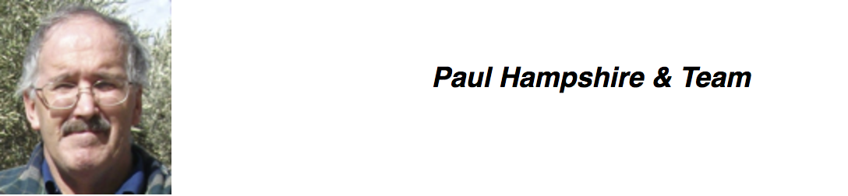
Sydney Tikkun Olam Report
The handing out of food hampers has continued over the past year to build relationships with our Jewish friends and neighbours. The hampers continue to give us the ability to move closer to the individuals and their families and in quite a number of occasions we have openly spoken about Yeshua. Sadly one of our friends passed away during the year but we are still seeing his widow and daughter.
I would like to thank Harry and the people of Tikkun Olam for the wonderful hampers that have given opportunity for me to build strong friendships amongst wonderful Jewish people. I was invited to a large Passover celebration this year, in one of my friends’ house (with all their friends) and they appreciated my family’s presence greatly. With another Israeli, we have bonded like brothers. Also this friendship has opened doors to a Synagogue and close communications with a Rabbi. Although my Israeli friends are not very religious, I often find opportunity to talk about their scriptures and our mutual Messiah. Although I am an enigma to them, it does provoke them (I believe) to jealousy and to find out more about their scriptures and our God. Thank you again for your ministry that can speak louder than words and can build bridges, where there once was a great divide.
I have been delivering hampers for each festival over the last year to a young Israeli mum that I meet with regularly. The family struggles financially but nevertheless regularly invites other Israeli families to celebrate festivals with them and she is always very grateful for the hampers. A few days ago, in the presence of another Jewish couple she started a conversation about eternal life and asked for my view on it. She knows that I am a believer in Yeshua and I was able to share that Yeshua died for our sins so that all who believe in him may have eternal life. There was other discussion around this. Please pray that the conversation continues as we continue to meet. I feel that this was a breakthrough moment in which she started to call Yeshua by his name rather than Yeshu. Cathy

Adelaide Tikkun Olam Report
Our association with Tikkun Olam spans many years. Our appreciation of the same has allowed us to witness many testimonies and hampers received with gratitude. We give credit to efforts of a group of Christian women on the production of each personalized card and the many helpers on the assembly of these food hampers. We pray that the Ruach HaKodesh will move in a mighty was in Adelaide and across the world amongst our people Israel. The history of our Jewish people in Adelaide dates back to colonization in 1836. The Adelaide Hebrew congregation was established in 1848 and the first synagogue was consecrated in 1850. I remember as a child that this very building was decorated as a big Sukkah. A new and much bigger synagogue was consecrated in 1871. A service attendance roster was established soon after and those who failed to attend were fined!! I am a little biased and believe that I grew up in the best time amongst the Jewish community in Adelaide.

Make a Donation to Tikkun Olam
Making a donation to Tikkun Olam will provide a generous food hamper. This fund is tax deductible as the funds are used for benevolence. If you would like to make regular monthly support we can arrange set up with your bank. So please consider to make a donation towards helping in a practical and spiritual way those needy Jewish folks in our local community. Note: Please specify your donation towards Tikkun Olam in order to receive a tax-deductible receipt.
We as the Messianic community strive to see that Tikkun Olam creates not only blessing to the world, but also “kedushah”, a life of sanctity, purpose, and meaning. Join with us as we learn to give to those in physical and spiritual need in the Jewish community throughout Australia.
Volunteers Wanted - Be a Part of Tikkun Olam!
We are looking for reliable and committed volunteers to help pack and deliver food hampers to needy Jewish people. If you wish to find out more please email our offices atenquiries@celebratemessiah.com.au

