TIKKUN OLAM EOFY REPORT 2021 – 2022

Welcome to Tikkun Olam end of financial year 2021 – 2022 report.

Many Christians of varying denominations regard their faith as having developed from Jesus’s rejection of Judaism. But Jesus was a faithful Jew who respected and protected Jewish traditions, practices, and laws.

Unfortunately, antisemitism is still alive. And while remaining mostly under the surface, history teaches us that it’s only a matter of time before it erupts.

Tikkun Olam has a deep passion for education which includes building spiritual and social bridges focusing on building messianic community and Jewish identity.

Victoria 250
News South Wales 80
Australian Capital Territory 20
Western Australia 275
Queensland 20
Basic Food Hampers Perth and Victoria 130

TOTAL NUMBER OF FESTIVAL AND BASIC FOOD HAMPERS 775 = $87,000.00

Thank you for your generous support

Donating to Tikkun Olam will provide a generous food hamper. This fund is tax deductible as the funds are used for benevolence. If you would like to make regular monthly support, we can arrange set up with your bank. So please consider donating towards helping in a practical and spiritual way those needy Jewish folks in our local community. An online donation can be made through our website http://www.celebratemessiah.com.au/donate.html Please specify your donation towards Tikkun Olam to receive a tax-deductible receipt.

We as the Messianic community strive to see that Tikkun Olam creates not only blessing to the world, but also “kedushah”, a life of sanctity, purpose, and meaning. Join with us as we learn to give to those in physical and spiritual need in the Jewish community throughout Australia.

May God Bless and be with you.

Barry Buirski and team

Volunteering makes a huge difference. Our passionate and dedicated volunteers continue to be an integral part of Tikkun Olam and aid our recipients through social, cultural, and spiritual giving.

233 Volunteers have partnered with us in 2021-2022 for card making, purchasing, packing, and delivering.

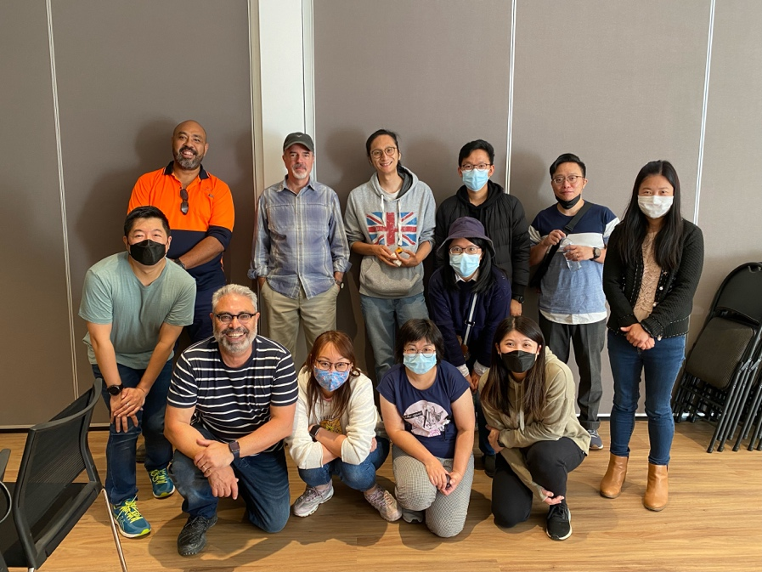
Meet our volunteer Peggie – (front row 2nd from left)

Why did you decide to become a volunteer at Tikkun Olam? I wanted to step out of my comfort zone and challenge myself to try something different, so I took the opportunity to help out at Tikkun Olam.

What do you enjoy most about being a volunteer at Tikkun Olam? Getting involved in Tikkun Olam is a great way to learn more about Jewish festivals and community. I was so fulfilled and joyful to share God's love with the Jews by sending them Tikkun Olam gift hampers and chatting with them during every visit.

How much of an impact do you feel your volunteering has had on others? They felt so much loved and cared for and were grateful for the help of a group of non-Jews.

Bendigo and Adelaide Church of Christ Tikkun Olam Card Making Team Report: -

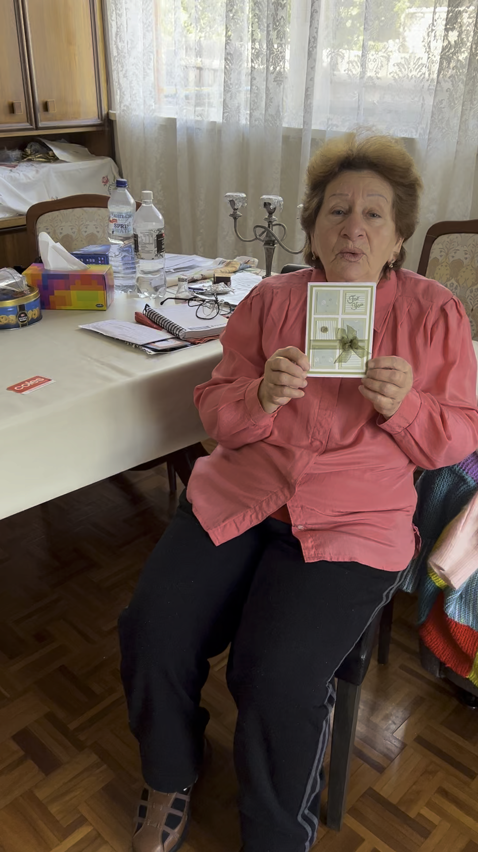
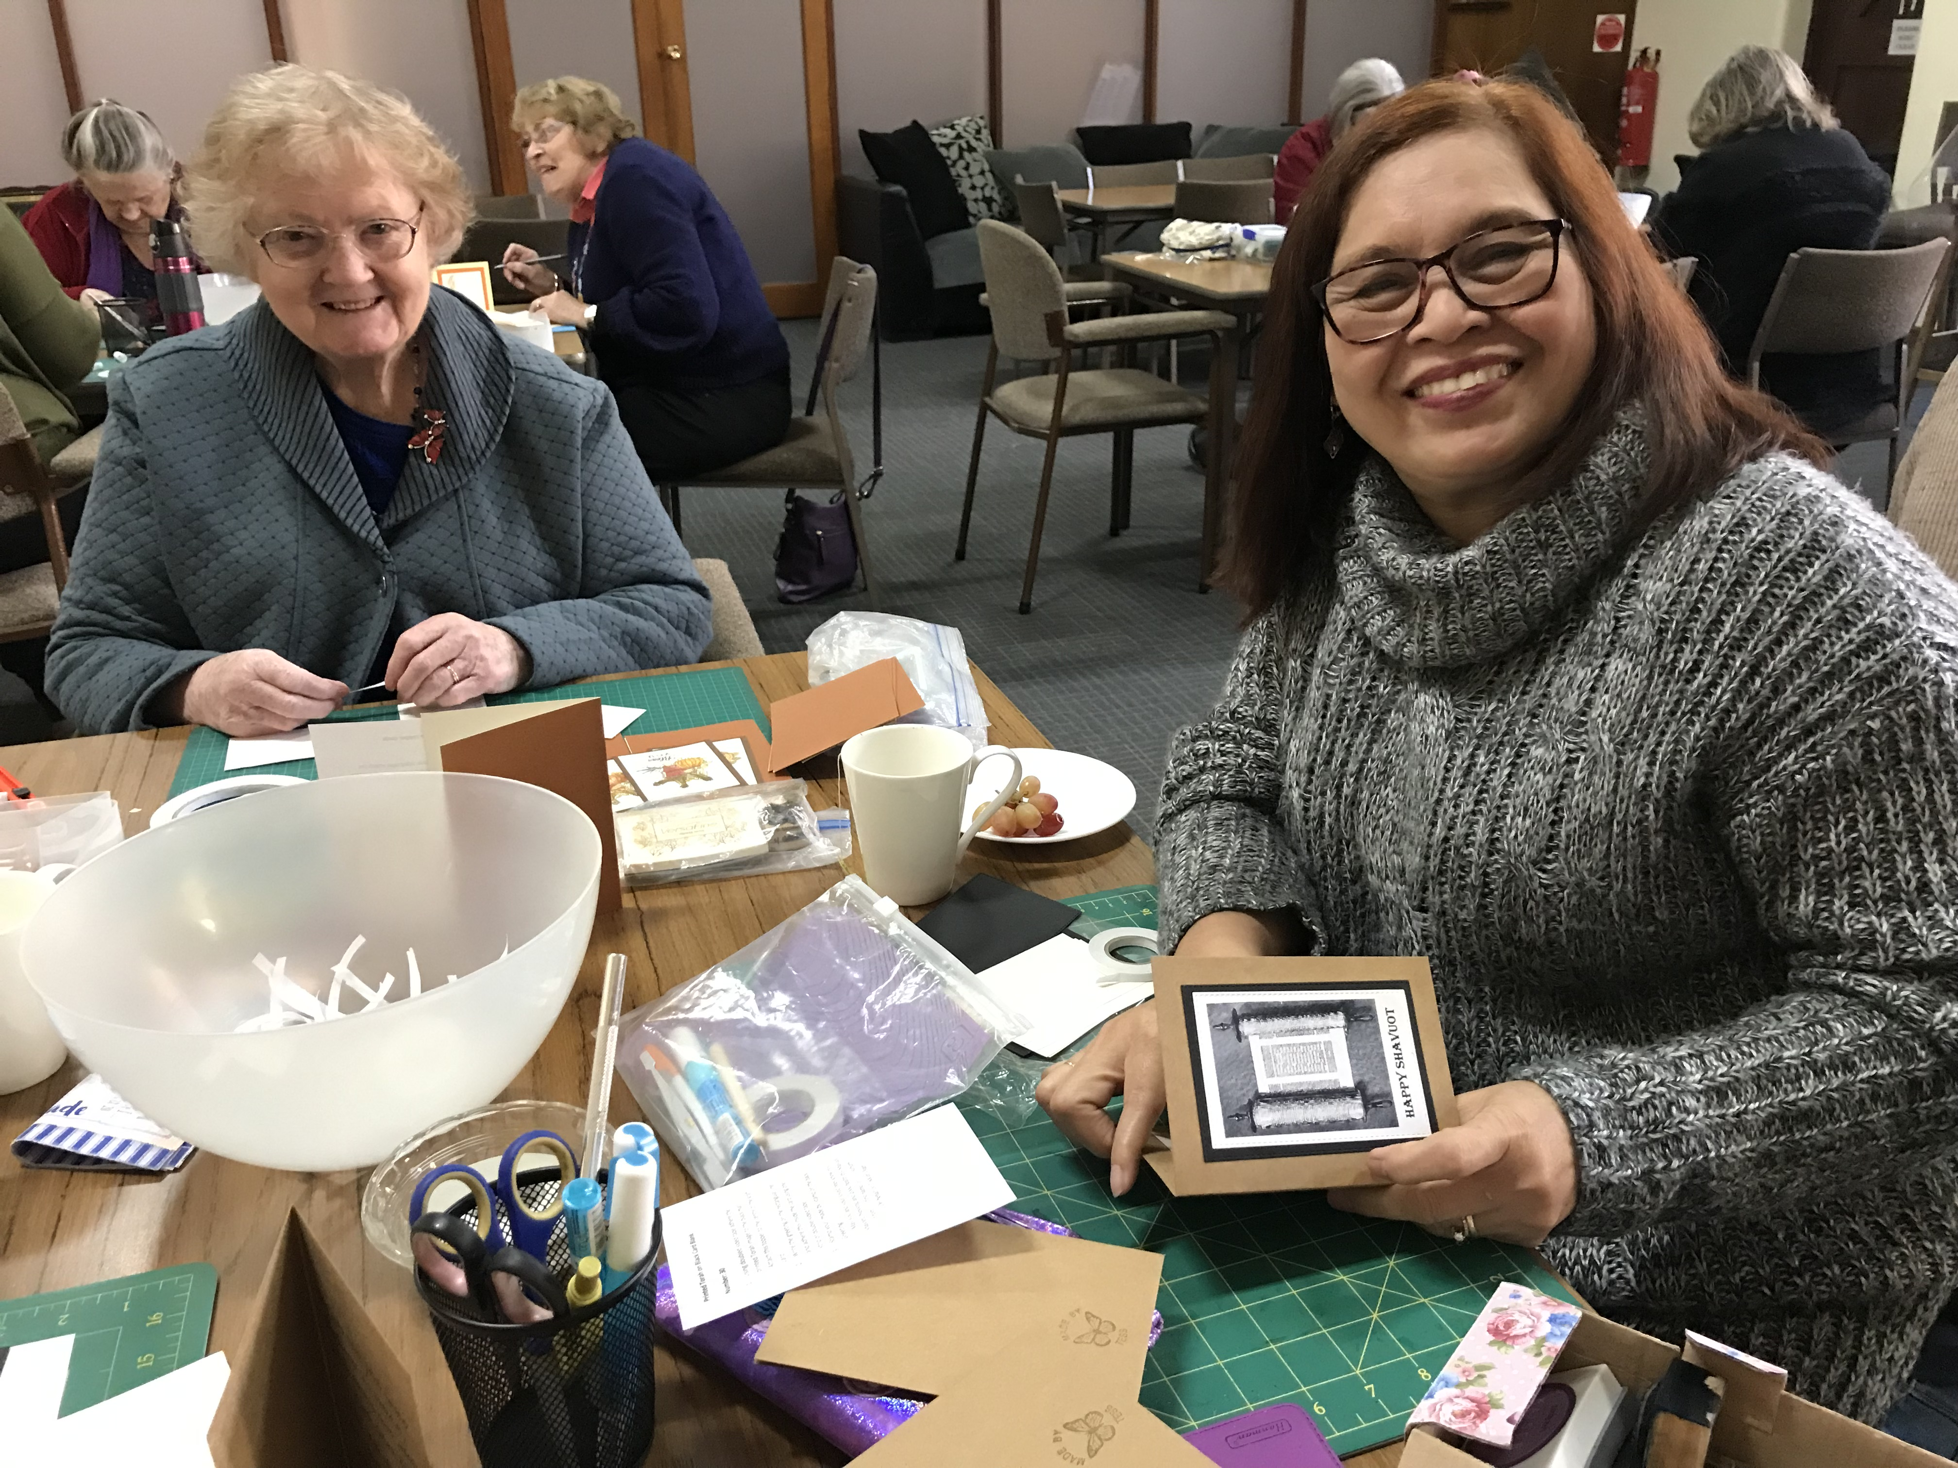
The team at Bendigo has been greatly encouraged in the Tikkun Olam ministry during 2021-2022 and we thank God for all He has done. It has been a blessing to meet again in person and enjoy making cards together after the restrictions of 2020 and early 2021. Our numbers have increased to 16 regular card makers. Most are from the Bendigo Church of Christ, but we are also delighted that ladies from other churches join with us in this ministry. When Barry circulated a video of one of the recipients rejoicing over one of the cards, we had made we were thrilled. It was so encouraging to be able to connect with a recipient in this way and we felt so rewarded for our endeavours. Thank you so much for this encouragement. The team were delighted to begin a new venture in 2022, making additional cards to accompany the monthly hampers. We have enjoyed broadening the style of cards and meeting in small groups to achieve the additional 140 cards required. We were also delighted to create additional cards for the Feast Day hampers to meet the increased demand. And finally, a wonderful encouragement from the Perth team: we received a hamper of goodies which we shared in a special morning tea. Jenny Lloyd phoned us whilst we were in a workshop and shared a greeting with the whole team. Totally unexpected and greatly appreciated! We pray that God will continue to use all of us to further His kingdom in this ministry.

Ruth on behalf of the Bendigo team
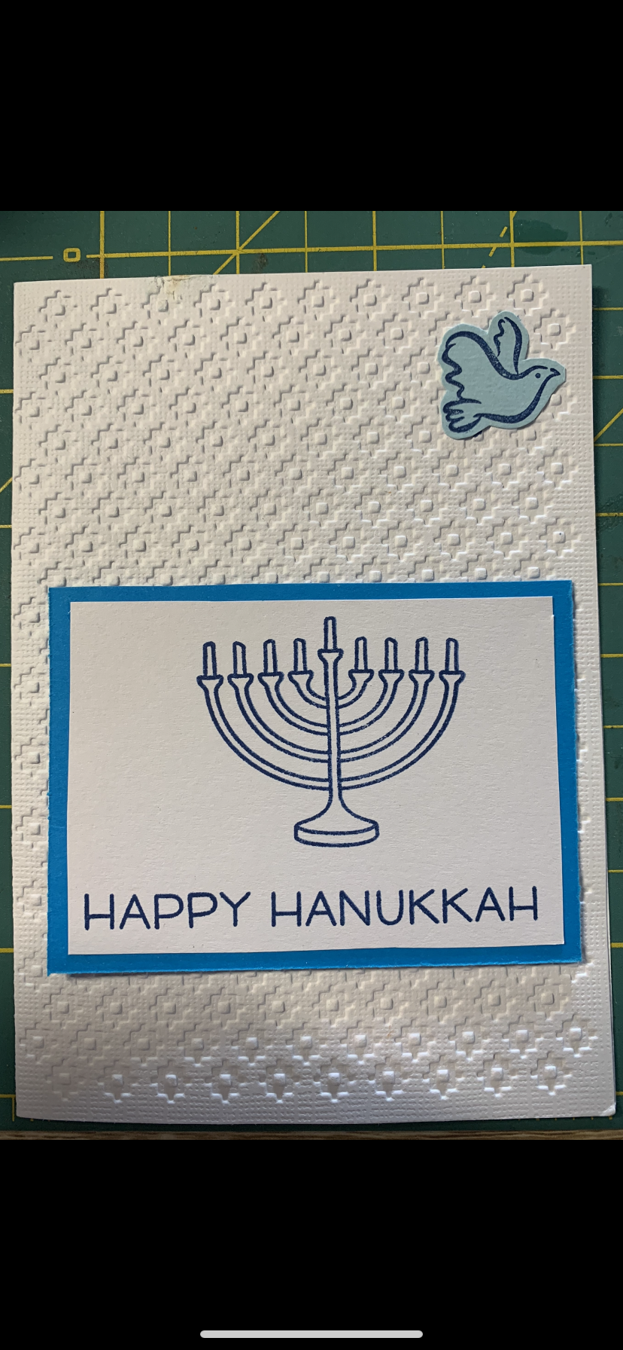
We, Pastor Neil, and I moved to Adelaide to live at the end of March. It was such a blessing to receive a surprise package recently from Jacqui Howse in Ballarat, who used to help me make the cards. The package contained many blank cards and envelopes which I appreciated very much. Jacqui continues to pray for the people who are reached with the packages from Tikkun Olam. We feel blessed to have a part in this ministry and to see many Jewish people come to faith in Jesus. God bless you richly as you serve God in Tikkun Olam. Barry, for the blessing of being involved in Tikkun Olam. Jacqui and I have enjoyed the time together making the cards and praying for the people they will go to. May God continue to use this ministry to reach Jewish people for Jesus Christ. Shalom and God bless.

Robyn and Jacqui on behalf of the Adelaide team

Brisbane Tikkun Olam Report: -
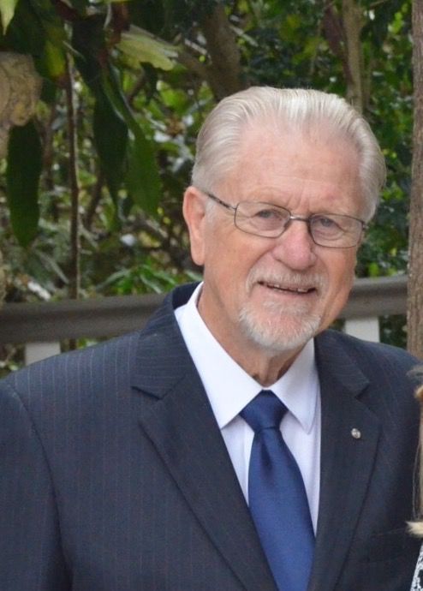
Thank you, Barry, for the opportunity of distributing items of the foods provided by Tikkun Olam to Jewish folk in SE Queensland. The situation over these last two years has been a little more complicated due to the circumstances of the pandemic, though it is now less so as restrictions have now been eased. It is nevertheless greatly appreciated by the recipients. Sincere thanks to the generous supporters who make this all possible and to the ladies who prepare and send the beautiful greeting cards appropriate for each festival. To all those involved in this worthwhile project - many thanks.

Fraser

Canberra Tikkun Olam Report: -

We have new people to give out the Tikkun Olam bags to due to our Passover – praise God!
A sad story occurred with our Passover – one of our Canberra team invited a Jewish lady, but she couldn’t find her way to the venue that evening of Passover, and thus missed out on a wonderful night, and was deeply upset. Out of that, we then promptly delivered her a Haggadah, some Passover goodies, along with a Tikkun Olam gift hamper, and she is now very grateful to receive the ongoing gift hampers at the feasts. She attended our Shavuot service last Saturday and was really stunned by Robert’s preaching of the Word, along with the beautiful dancing, and she stayed to have lunch with us all. Many blessings.

Irwin and Jill

Sydney Tikkun Olam Report: -

Dear Tikkun Olam, thank you for your continuing help with the gift hampers during the High Holidays. Receiving these gift hampers during those time have been a huge blessing. Once again. Thank you. Kind regards Oryit

Hi Harry, I cannot believe that a year has flown by. It is always wonderful to celebrate the festivals with you and to sample the wonderful food products in the gift hampers. It adds to the enjoyment of the festival. Bessie is 91 today. Regards Debbie and Bessie

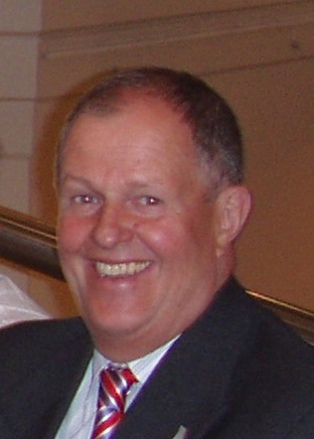
Hi Harry, I just want to say thank you so much for the fantastic gift hampers that we have received. I’d also like to say that the cards are beautiful and obviously handmade which must take lots of time and care. We truly appreciate your thoughtfulness. Thank you again. Kind Regards Linda

Harry and team

Perth Tikkun Olam Report:

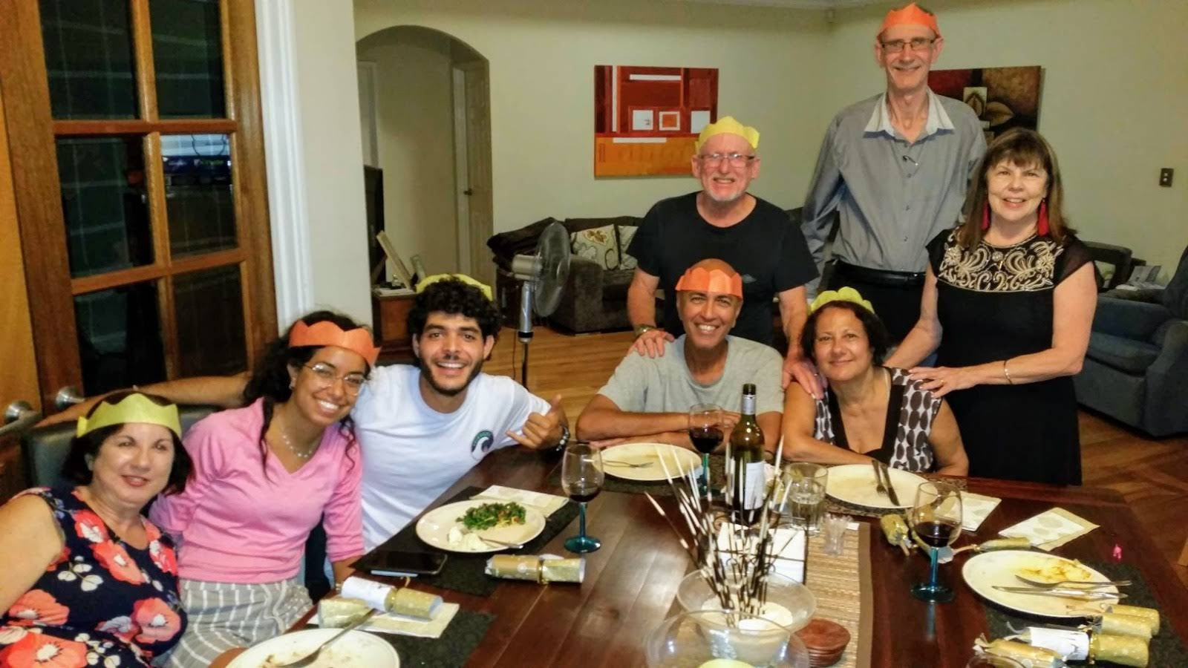
Pastor Peter & Leanne Boland who have managed Perth Tikkun Olam for the past 12 years are moving to Kalbarri in country WA hence their leadership will be passed onto Jenny Di Stasio who will continue the role of Tikkun Olam in Perth. Peter has been a close and trusted friend for many years and will be greatly missed by the team in Perth and me. Barry

In approximately 2010 I was approached by Barry Buirski to head up Tikkun Olam in Perth Western Australia. Commencing with just 6 gift hampers and no contacts we relied heavily on Hashem to provide contacts. In 2022 we now distribute 55 gift hampers, and we continue to grow, all praise to Hashem. During the past 12 years, many friendships were made, lives were touched by Hashem’s love and the generosity of those who support this ministry.

It has been an absolute honour to serve the Jewish community of Perth and I am eternally grateful for the opportunity to spread the love of Yeshua to those who I have met along the way.

I leave this position in the very capable hands of Jenny and the team and I look forward to hearing of many more lives being touched. Peter and Leanne Boland

Following is Sean's response after receiving our Tikkun Olam gift hamper. “He said it was so special to think that someone is thinking about me, and he was grateful that he was able to say thank you in person this time.” Sean

Mikhail another Tikkun Olam recipient was so impressed with the card that "Jess" sent her and has put it on display. She also appreciates all the work as she used to go with her father to purchase everything and help deliver. Mikhail

Dear Barry, Peter supplied me Tikkun Olam gift hampers, which I deliver and continues to make an incredible impact on the Jewish community in Perth. Some were elderly, or single parents who were "doing it hard". It was often the only gifts they received as well as being recognition of them simply as human beings who were doing their best.

Alas, the number of Tikkun Olam gift hampers I have distributed has decreased over the years - some due to death of elderly clients - others thankfully who have worked through issues and felt they no longer needed the Tikkun Olam gift hampers and felt they should go to families in more need than they felt themselves to be which, after all, is the outcome we all hope to achieve with those we work with.

I now deliver the remainder of Tikkun Olam gift hampers and still consider myself to be privileged to be involved. I can assure you that the Tikkun Olam gift hampers make an incredible difference to recipients. Particularly for single parents, it is a joy to hear of their children excitedly opening the contents of the gift hampers to discover items often beyond the capacity of their parents to afford.

My best wishes and thanks for the wonderful work you and your supporters do and give so freely. Kindest regards - Iris

Shalom Barry, hope you're keeping well. I'm a long-standing friend of Peter and Leanne and I've been involved in the allocation of some Tikkun Olam gift hampers to members of our Jewish community. I too am a Jewish believer in Yeshua for over forty years now. I would like to tell you how the recipients of your wonderful generosity appreciate their Tikkun Olam gift hamper of goodies & stuff they wouldn't be able to afford to buy themselves. Peter has been so faithful in delivering the Tikkun Olam gift hampers and could always be relied on to do so. I deal a lot with elderly folk and with people from all walks of life, as I'm a disability pensioner myself. So once again I commend you and Peter on a task well done. Kind Regards - Denise

Peter, Jenny, and team

Melbourne Tikkun Olam Report: -
A special thank you to all our Tikkun Olam leaders and volunteers across Australia. Without you we would not be able to keep going throughout the Covid pandemic. You have brought the fragrance of our Messiah Yeshua to a very troubled world. Every volunteer in Tikkun Olam is vital to bring about the Holy Spirit action that is needed in our Jewish communities across Australia.

Tikkun Olam and Covid 19: -

We were able to increase and continue our supply of Tikkun Olam Holiday and Monthly Gift Hampers. The extraordinary example of two Chinese churches here in Melbourne has deeply moved me and those who receive our Tikkun Olam gift hampers. Central Chinese Baptist Church Pastor Alex Lam and Eastern Chinese Baptist Church Pastor Samuel Chan continue to encourage the members of their congregations to support the Jewish Community in this most humbling way. Brothers you are a great blessing to my Jewish community in Australia. The responses we get from the recipients continue to be of gratitude joy and genuine thankfulness for our continued support of them currently. Following are testimonies from our recipients.
Thank you for the greeting and for being very generous. I appreciate being remembered. I also wish you health and happiness and peace. Warmest regards. Rona

Tikkun Olam reaching out to Ukrainian refugees.

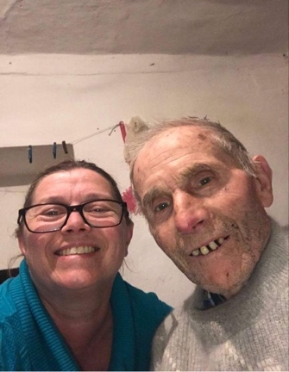
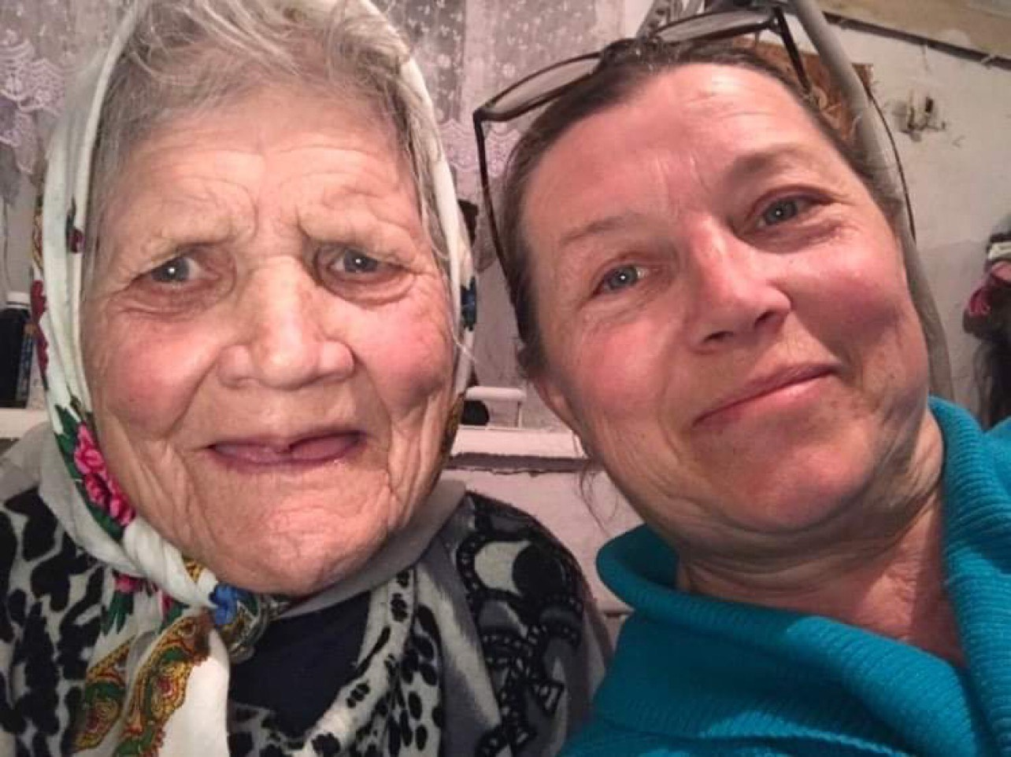
Dear Barry, the gift hampers we receive from Tikkun Olam they are so helpful, this past week. I thought I was going to have to take money out of the rent account to buy food so I’m so appreciative. I spoke to my mum early this morning, I’m obviously very concerned with her and my sisters and the rest of my extended family’s safety. She was calm and trusting God as she always does. She has no plans to leave or abandon my grandparents, my grandma can’t be moved and needs constant care. My family are in the Odeskya oblast in a village about 60km from the Moldova border. Things were still quiet there when I spoke to her at 6am this morning, except that there was a long line at the bank and supermarkets were busy. Hi Barry, my mum and family will be leaving tomorrow to make their way to the border crossing into Moldova. Could you please ask people to pray that it’s a safe journey and they don’t have any problems. Hi Barry, we have 3 family members approved so far and are hoping to have 4 more approved today. Presently Anna’s family is now safe in Melbourne. My son-in-law Asher Hirsch assisted with the process of visas for some of Anna’s family members in order that they might find refuge in Melbourne Australia.

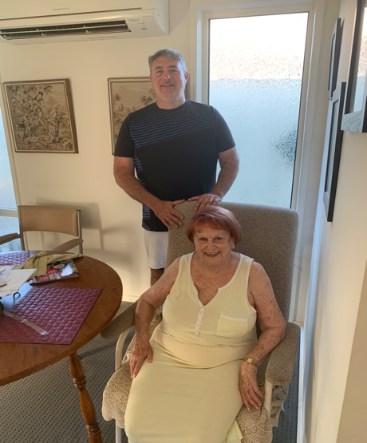
Thank you so much for the support that you have provided us. The food gift vouchers are extremely important, so it provides us with fresh produce such as fish, meat, chicken, vegetables, and fruit for our family.

The cash money assists our family with payments for electricity, gas water and other essentials as sanitary items for the females in the family.

Toiletries, toilet paper masks sanitisers cleaning products and food for the pets.
Without this help we would extremely struggle especially in the last few months that I am caring for my mother with dementia. Thank you so much for keeping our family of 6 afloat fulfilling basic needs. Regards The Olascoaga family

Shalom, just wanted to take this opportunity to thank Tikkun Olam for such generous food gift vouchers and food gift hampers we receive from them on a regular basis. Having this support, especially when you need to cover medical bills, pay the rent etc. and having 3 kids means the world to us. I really appreciate Tikkun Olam being there during this time. THANK YOU for your wonderful job. Best Regards Larisa Ulianitsky

A big thank you to you Barry for doing such an amazing job. I am sure God bless you and your amazing family for what you do to others. Your kindness is not unnoticed. Lots of love and prayers for good health and happiness going to you and your family. Thank you and shalom.
Best Regards Irina

