TIKKUN OLAM EOFY REPORT 2017 – 2018

Welcome to Tikkun Olam end of financial year 2017 – 2018 report.

We are delighted to have you as a valued member of Tikkun Olam. Your support directly helps us engage positively with the marginalized in the Jewish community.

We have a hardworking team at Tikkun Olam and In the financial year of 2017-2018 we been able to distribute in: -
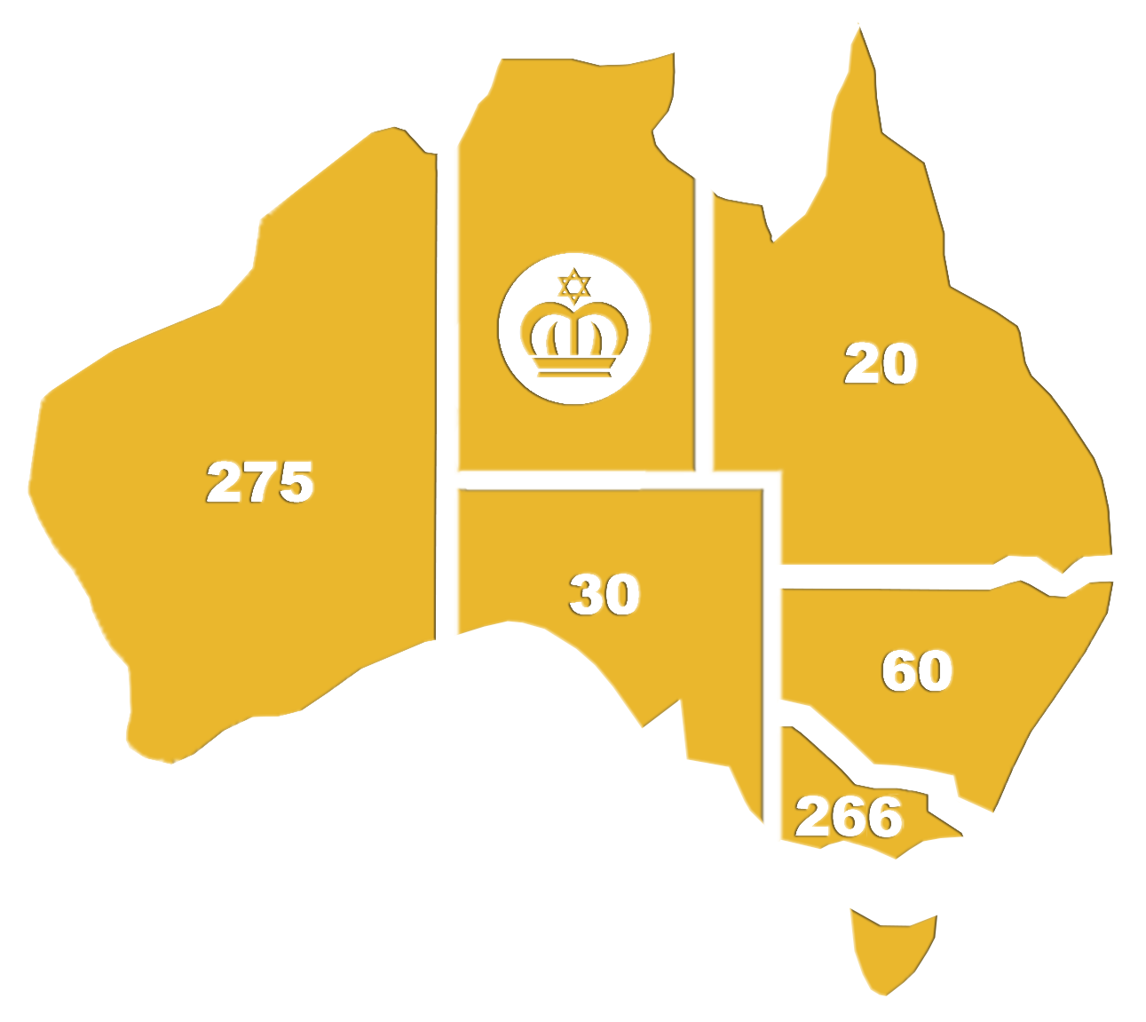
Victoria 242
News South Wales 60
South Australia 30
Western Australia 275
Queensland 20
Basic Food Hampers Victoria 24

TOTAL NUMBER OF FESTIVAL AND BASIC FOOD HAMPERS 651 = $36,000.00

153 Volunteers have partnered with us in 2017-2018 for card making, purchasing, packing and delivering.

These accomplishments would not be possible without your support. You add strength to our numbers and volume to our voice in the Jewish community of Australia.

Our work is funded by the generous donations we receive from our members which help to underwrite the cost of food distribution into needy Jewish homes across Australia. Presently we have significant gaps in our funding and would ask you to prayerfully consider how you can support the continuation of food hampers into the Jewish community. Following are testimonies from the recipients and volunteers of Tikkun Olam in Australia.

Bendigo Church of Christ Tikkun Olam Card Making Team Report: -

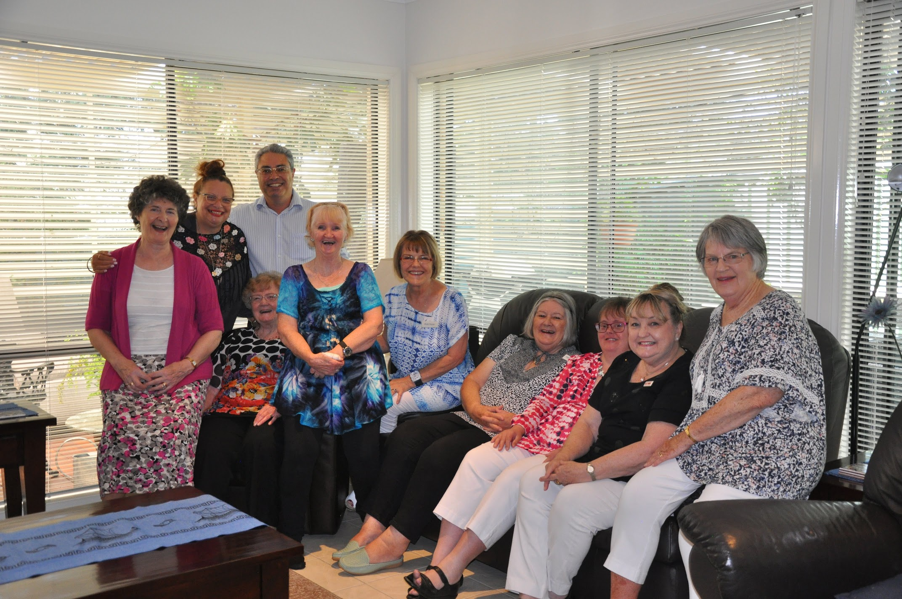
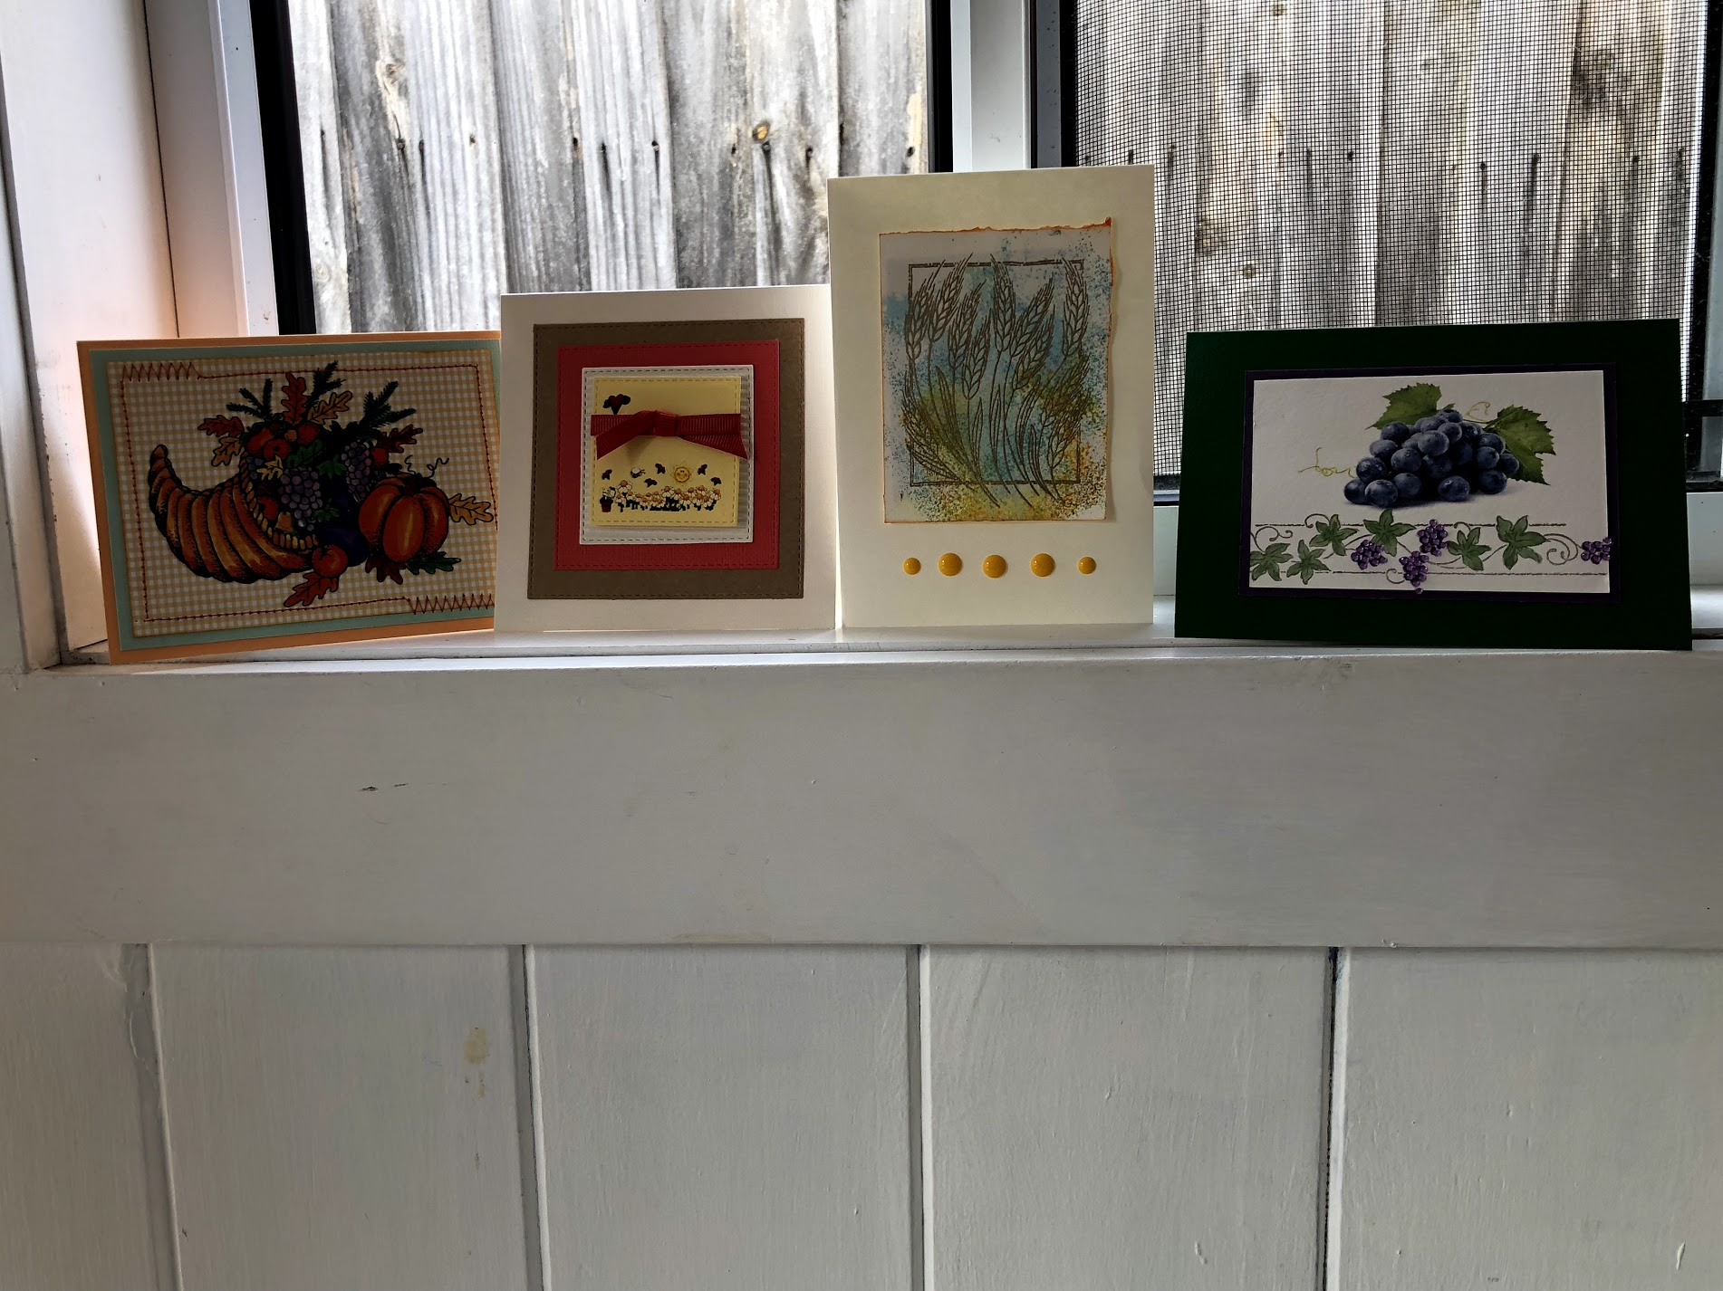
Involvement in the Tikkun Olam ministry of Celebrate Messiah has provided a unique opportunity to serve God, build connections in our church community and develop paper crafting skills Five times a year a group of 10-12 women and girls meet at the Bendigo Church of Christ to create the 132 cards which accompany the Tikkun Olam hampers provided for each of the five festivals. Prior to the scheduled workshop a few members of the group meet to create new designs that will reflect the meaning of the festival. The Bendigo Church of Christ supports Tikkun Olam with funds towards the materials and postage and this is matched by a great generosity of time and effort by the team.

We gain new card making skills, but most of all we learn about the Biblical basis of the ‘Feasts of the Lord’ and how God’s plans and purposes are fulfilled in and for His people. Through these times together we have developed a ‘keen heart’ for the people of Israel. At the end of each session we pray over the cards we have made, that God will use them to bless and encourage His people and to create opportunities for those delivering the hampers to talk with recipients about Yeshua. This year we enjoyed a visit to Bendigo from Barry and Melinda Buirski. As a team we were able to share a meal with them and learn more about the Tikkun Olam ministry. We are blessed to serve in such a unique way. Ruth Sloan on behalf of the Bendigo Church of Christ Tikkun Olam Card Making Team

Brisbane Tikkun Olam Report: -
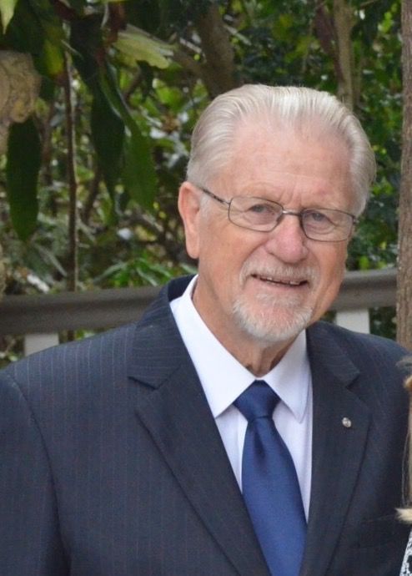
Once again this year, it has been a privilege to be engaged in the worthwhile ministry of distributing food hampers during the feast times. My involvement reaches folk within the Jewish communities in Queensland stretching across the Gold Coast, Brisbane and the Sunshine Coast. This is an all-inclusive concentration of Orthodox, Liberal and Messianic Jewish people, including some people in retirement villages, widows and widowers,
It does my own heart good to receive their spontaneous appreciation upon my arrival with the hampers. So a huge ‘thank you’ to the supporters of Tikkun Olam, who enable this support and blessed provision.
Tikkun Olam, I sincerely appreciate the opportunity to be a small link in the much bigger chain of collaborators who embrace this invaluable project. Thanks also to the ladies who provide the wonderful inspirational cards.
Fraser Harding and team

Sydney Tikkun Olam Report: -

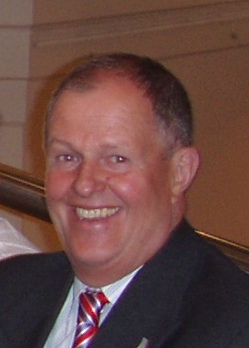
This has been a very fruitful year in building on our Jewish relationships of the previous year. The food hampers as well as the lovely cards have allowed us to become personal friends of 12 Jewish families. We are now part of these families, and calls to assist with personal issues as well as introductions to their friends happens all the time. One of the people we have been giving the food hampers to recently gave his heart to the Lord! We are very grateful for these opportunities and continue to pray that the Lord will take the scales from these lovely people’s eyes. As some of these people are very old we have to continue to press in. What a pleasure to have the food hampers to help us open the doors.

The family we supported with Tikkun Olam made aliyah to Israel early this year. They were always very grateful for the extra help and open to hearing my beliefs about Messiah, which I spoke to them about on various occasions. Please pray with me that they meet up with believers in Israel and discover the truth about Yeshua for themselves.

We gave food hampers to Jewish people across the Sydney Metro area. We have distributed most of the food hampers to a Jewish Family in Baulkham Hills who in turn invites the Jewish Community via her Facebook page. Her daughter sent us a lovely thank you card. I have a little opening with this family now, and am praying that God will bring us to a closer relationship. Another food hamper went to upper Hawkesbury area, which was shared among the community. They share one food hamper with several families in the community. They too sent a thank you card.

Harry Haman and team

Perth Tikkun Olam Report: -

I would like to thank you about the warm feeling I receive from Tikkun Olam every time at Jewish holidays when I receive the bag with the groceries and other things. Your donation is so important to my family. When I receive the bag it gives me a big smile on my face as it really helps us. Your mitzvah is so important to so many people. It gives us feel secure, as we know that it will bring food and other gifts, which cost a lot of money, which we don't always have. So, once again I would like to say thank you with such a beautiful and such an important thing to my family and to all the people who need your donation. Sincerely and from the bottom of my heart. Sarit

I live on my own in Perth and my only relative, my son Tony, lives in Canberra so your visits and gifts bring so much joy to my life - to know that people really care about me and that your gifts are made possible by your organisation in Melbourne. The food hampers are wonderful and include many things that are normally beyond my ability to buy and bring an extra joy to the holidays they represent. I would appreciate you letting your colleagues in Melbourne know just how much joy their gifts bring to me. They let me celebrate in a way I normally couldn't do. Also, you and your colleagues’ visits to and consideration for me is also much appreciated - I enjoy the little time we have together. With sincere best wishes.

I can't thank you enough for your kindness. I've had a hard time over the last couple of years, due to a long-term illness and unemployment. It's been tough keeping a roof over our heads, and food, unfortunately, is often kept to the bare minimum. Those brown paper bags are always a real treat for us - they've nourished us and kept our morale up, especially on the holidays but also, when food was just running low. It's good to know there are caring people like you who do this selfless work without expecting a reward, which you so deserve. It's an incredible blessing something that really does help mend the world. Thank you so much for caring Tikkun Olam!

This is to confirm the over whelming support for Peter Boland in regularly dropping off various kosher food items so that my wife and I can enjoy this mitzvah. We are both very appreciative of Tikkun Olam's generosity and we only have praise for Peter's good deed s. We would !ike to say a very big thank you to Peter for dropping off the food hampers to us. Thanking you once again.

I just want to thank you for your support for your food hampers over the Yom Tov's I have had in the past. I especially liked the cards sent and the effort put into them, as I am a single man living on my own outside the community, for the cheaper rent it is more economically viable here. Thank you, for your continued support.

I've been meaning to write for some time to acknowledge the great working relationship we have built over the years - as well as the wonderful relationship you and your colleagues have built up with my numerous clients who speak so highly of you. Such joy you bring to them all. The only "complaint " they have is that you can't stay longer with each and ever y one! However, they do understand that you have so many to see that time is unfortunately limited - they would have you there for hours. Many of the people you visit are socially isolated and some with no family members in Perth, so them especially are touched by the visits by you and your colleagues, the generosity of your gifts and the thoughts behind them. I've also had comments on the beautiful cards from your members in Melbourne, which bring an added personal touch, which they love. Please send best wishes and sincere thanks to all involved – Iris, Social Worker JewishCare.

This is testimony to the amazing donations that are being gifted. I am one of the families that receive the food hampers whenever it’s possible which helps me put food on my table and actually spoil my kids a little with the sweet treats! It takes a lot to be open to receiving when we are taught to give to charity, not take it. But as life changed for me a few years ago, I learnt to have an allowance of who I be and accept the ongoing support that I am able to receive. Your ongoing donations and support is beyond words – gratitude.

“I wanted to thank you and let you know how much we appreciate the chagim food hampers we receive from you. When my girls see the bag they get so excited and open it to have a look what goodies we got. For them it’s exciting but for me it’s a blessing. We get from you necessary groceries that just make life easier and help us celebrate the holidays. Thank you so much for your thoughtful kindness.

Peter Boland and team

Melbourne Tikkun Olam Report: -

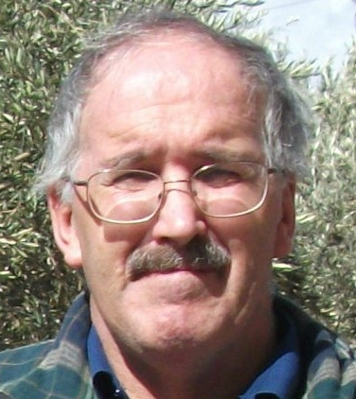
In the last year, I've had the privilege of being invited into the homes of a few Tikkun Olam recipients. In one home, it has become a habit that I have a cup of tea and biscuits with *Zelda (not her real name). I met Zelda through her husband *Zig (not his real name) who got lost while walking and arrived at our driveway 3 times! Through trial and error, we were able to find and walk him home. Zig has since gone to live in a local nursing home.

Zelda was very touched by a surprise gift from Tikkun Olam and has accepted food hampers, but always with the view that we're growing in a friendly relationship. Zelda is not religious but celebrates the Jewish feasts with her extended family. She has never forgotten how kind the people of Australia were to her when she was a migrant, having escaped from cruel treatment of the Jewish people in Russia. She is amazed that "the Church cares about the Jewish people" and would make contact and build bridges through Tikkun Olam. Hedy.

Thank you, for your generous and heartfelt gifts of food hampers for Shavuot and the months. Recently, even more so, has been a very trying time for my family and knowing and having your care and support for my entire family is really beyond words. Please accept my heartfelt Thanks and may Hashem bless all of you threefold for your wonderful work, all your prayers for Israel, our beloved homeland, which so small, stands fiercely against its foes and for your love, dedication, support and care of the Jewish people. All my gratitude to you and volunteers for all the hardships you go through to help us in these troublesome times. With warmest regards to you all for a healthy winter and beyond.

B, a long-term recipient of our food hampers, had a long conversation with Philippa a volunteer with Tikkun Olam. They talked about her husband who had fought in Israel’s war of Independence. An extraordinary conversation!

Paul Hampshire and team

Adelaide Tikkun Olam Report: -

Sometimes it feels like we're fighting to live another day but with Yeshua we do expect to win. Our lives over here are not easy. We solicit your prayers and expect a great victory. I know first hand that the assembled food hampers are prayed over and now the cards. As a result (and for another year), John and I have seen ' a pure love' handed over to grateful recipients again. Only recently I grabbed a Feast of Weeks card and could write a more extended message to a person that we showed a particular affection for. So now we can enjoy these handmade tools of trade as well. Wishing every state in Australia the ultimate success that Tikkun Olam is. We love the testimonies; we ourselves have many to share. Keep them coming.

Leslie Schwimmer and team

Making a donation to Tikkun Olam will provide a generous food hamper. This fund is tax deductible as the funds are used for benevolence. If you would like to make regular monthly support we can arrange it to be set up with your bank. So please consider making a donation towards helping in a practical and spiritual way those needy Jewish folks in our local community. An online donation can be made through our website http://www.celebratemessiah.com.au/donate.html
Please specify your donation is for Tikkun Olam in order to receive a tax-deductible receipt.

We as the Messianic community strive to see that Tikkun Olam creates not only blessing to the world, but also “kedushah”, a life of sanctity, purpose, and meaning. Join with us as we learn to give to those in physical and spiritual need in the Jewish community throughout Australia.

May God Bless and be with you,

Barry Buirski

